**PROJECT 2**

Deploying web server on Ubuntu Instance.

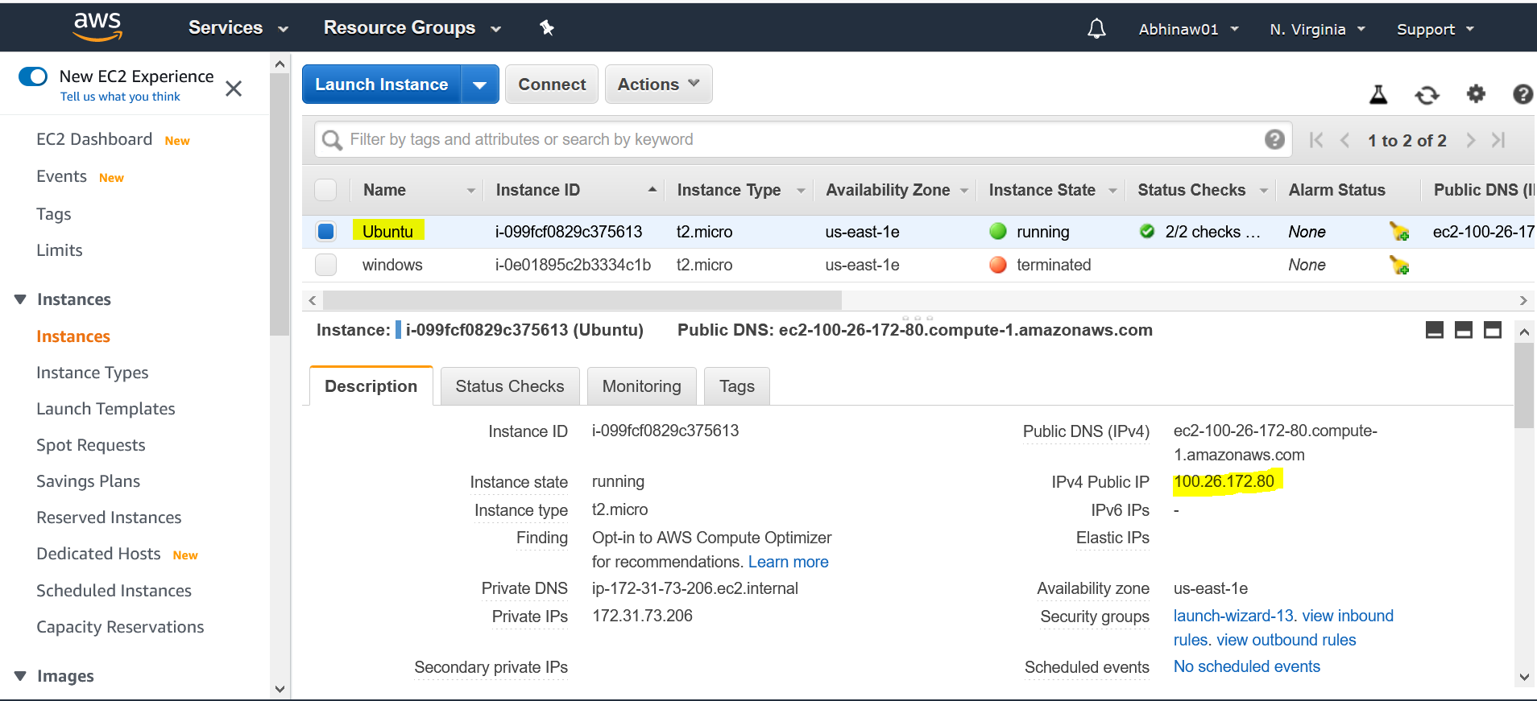

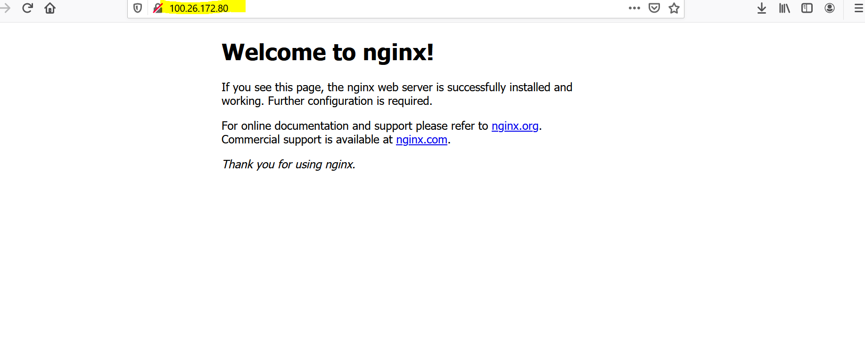

**PROJECT 1**

Deploying a web server in Windows instance.

**Solution:** I have launched the windows instance but not able connect using RDP Client. Facing issue wile connecting because of some security reasons, I am using my office system I feel that’s why. I will be able to deploy it on other system. Please accept my assignment with one project only. Below I am attaching screenshot with launched windows instance and errors.

